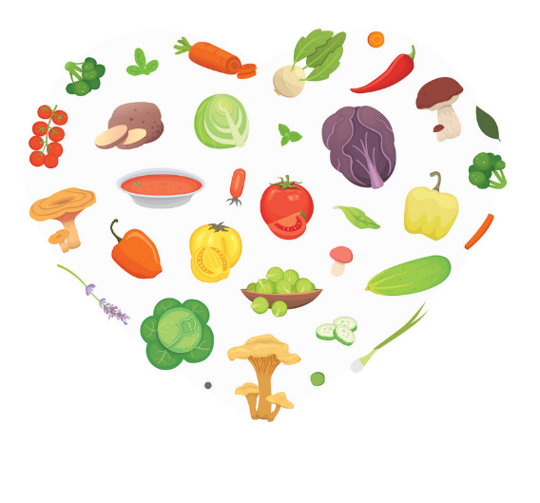

Healthy Eating Specifications

This document outlines specifies typical food and drink provided by parents to the children attending our early childhood service and is an appendix of our Healthy Eating Policy. This is a TUSLA directive under Regulation 19. Health, Welfare and the Development of the Child.

Usual snack foods include: | Sandwiches, Wraps, Pasta etc…  Yoghurt, Cheese etc…  Glasraí (Vegetables) - carrot or other veg sticks;  Torthaí (Fruit) - all fruit
We do not allow: (* chocking hazzard*) | *Large Marshmallows*, *Popcorn*, *Nuts* Sweets, Biscuits, Fizzy Drinks, Over sweetened juices, Crisps, NO NUT BUTTER.
Usual drinks include: | Uisce (water) is provided or child can take their own Milk or water.
Other Practices and Routines in relation to our service including any restrictions on food and snacks coming into the setting | The children have access to water at all times of the day and there are robust glass mugs which are easily washable in warm soapy water.  Lunches are to be placed in lunch boxes and stored in fridge.
How Birthday Parties/Celebrations are handled: | Parents can bring plain chocolate/chocolate cake (allergies checked and pre approved by Naíonra manager) still in wrapping.
Name on Lunchbox | Please put your child’s name on their lunch box and water bottle (We encourage reusable bottles).

